**DIARY PROJECT DATA 422 - WRANGLING**

| Week | When? | What?|

|-------|------|-----|

| 7 | Lab | group project official launch |

| 8 | Lab | fast prototyping |

| 9 | Lab | lighting presentations |

| 10 | Lab | group work |

| 11 | Lab | usability sessions |

| 12 | Lab | group work (for presentation) |

**Week 8: Sept. 16 - Sept. 20**

Topic Discussion

* Gain datasets
* Constrains:
  + our dataset is not tidy
  + missing values
  + not in dataframe format
  + obtaining a common variable to join datasets

**Week 9: Sept. 23 - Sept. 27**

Lighting Presentations

* Finalization of the topic - FOOD
* FOOD in NZ
  + Factors affecting import and export of food in NZ
  + Is Price Index
* Discussed the topic to Thomas and obtained feedback regarding the chosen topic
* Creation of GITHUB account for the group
* Group Meeting in Central Building searching for datasets

**Week 10: Sept. 30 - Oct. 4**

Group Work

* Scraping further related information
* Wrangling individual datasets
* Picture of Team 5 first group meeting

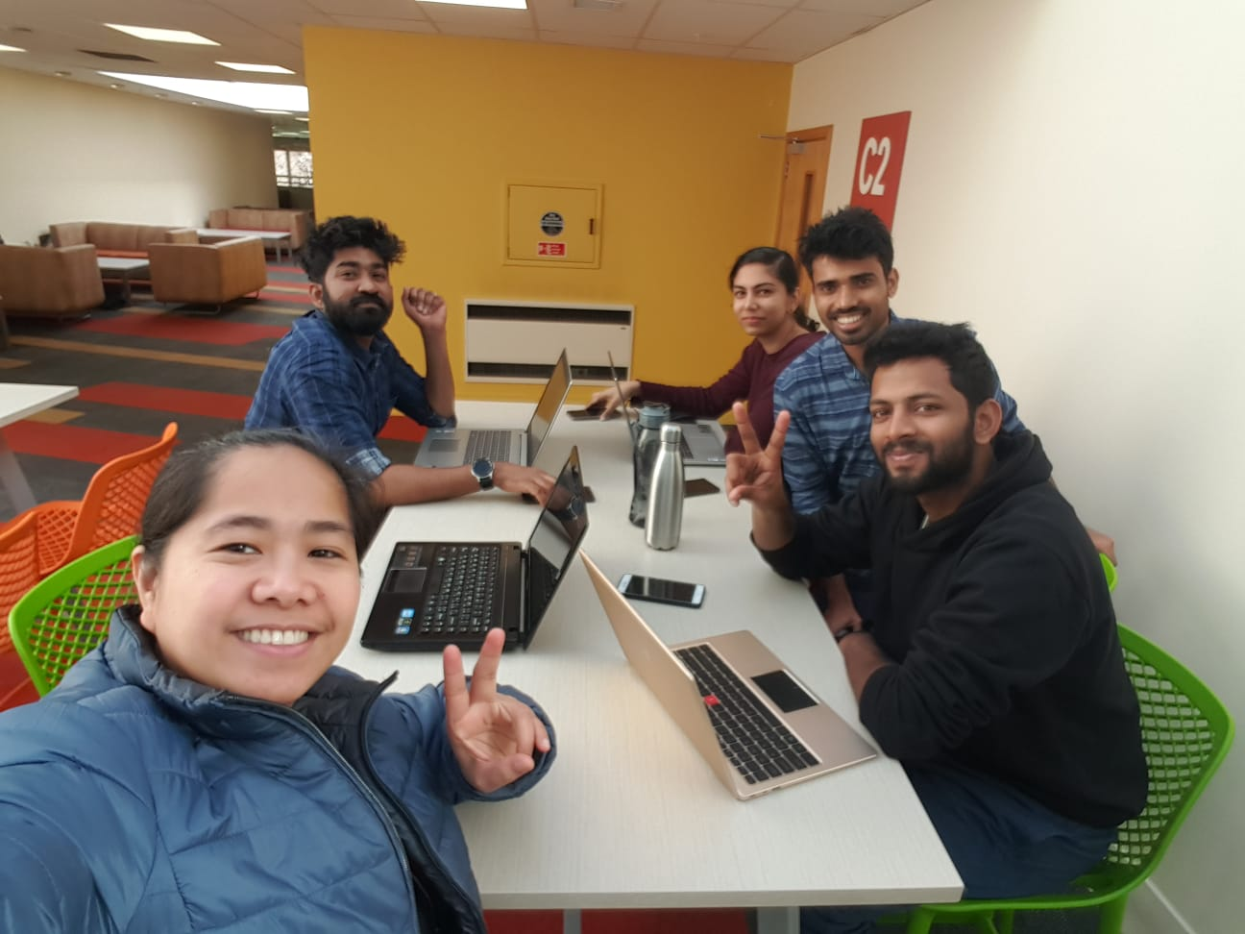

**Week 11: Oct. 7 - Oct. 11**

|  |  |  |
| --- | --- | --- |
| Dataset | Status | Updated By |
| ag-1areas-hect-farm07.xls | Initial cleaning | Gem |
| summ-livestock-farm-type-06.xls | Initial cleaning | Gem |
| Food_Price_Index_Selected_Monthly_Weighted_Average_Prices_for_New_Zealand_Monthly_June_2019.csv | Initial cleaning | Dipin |
| gstc-yejun17-tables.xlsx | Initial cleaning | Gem |
| overseas-merchandise-trade-january-2019.xlsx | Initial cleaning | Dipin, Anoop |
| Immigration detail.(web scrap) | Under process for scraping | Munnu |
| Diary | Under process | Gem |

**Week 12: Oct. 14 - Oct. 18**

|  |  |  |
| --- | --- | --- |
| Dataset | Status | Updated By |
| ag-1areas-hect-farm07.xls | Done cleaning | Gem |
| Plotting or joining datasets |  |
| summ-livestock-farm-type-06.xls | Done cleaning | Gem |
| Plotting or joining datasets |  |
| Food_Price_Index_Selected_Monthly_Weighted_Average_Prices_for_New_Zealand_Monthly_June_2019.csv | Done cleaning | Dipin |
| Plotting or joining datasets |  |
| gstc-yejun17-tables.xlsx | Done cleaning  Note: use only Tables 2 - 7 | Gem |
| Plotting or joining datasets |  |
| overseas-merchandise-trade-january-2019.xlsx | Cleaning under process | Dipin |
| Plotting or joining datasets |  |
| scraping | Web scraping under process | Munnu |
| Plotting or joining datasets |  |
| Diary | Under process | Gem |

Picture of Team 5 second group meeting:

